**Project:** Plant Watering system using ESP32, Moisture Sensor, DHT11 & 0.96" OLED

**Please print this page on **A4 page**, also check the PCB Layout Dimension.

**PCB Dimension:**

Width (X): **122 mm**

Height (Y): **65.5 mm**

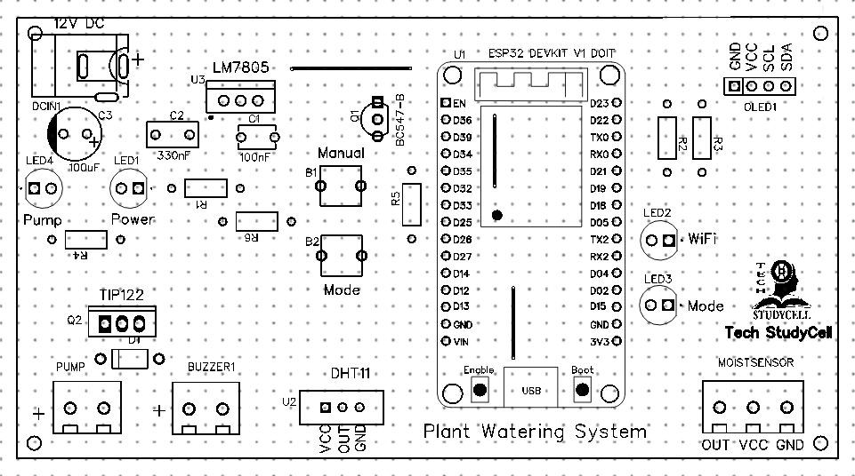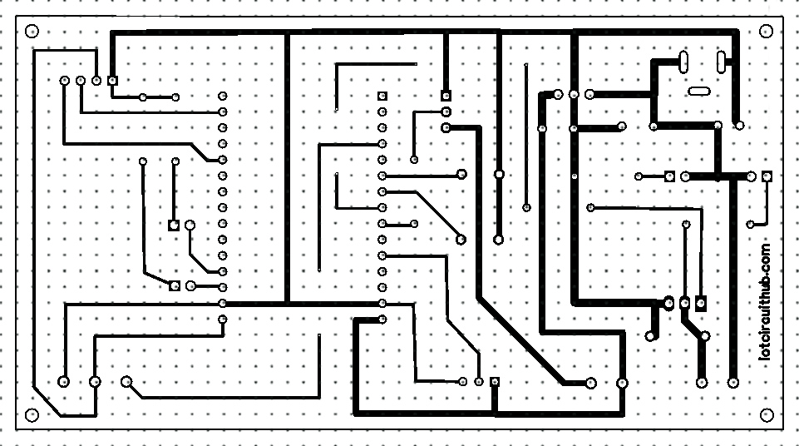

Related Tutorial Video Link:

For more such project visit: **https://** **iotcircuithub.com**

Also Finds Us @

Facebook: <https://www.facebook.com/techstudycell/>

Instagram: <https://www.instagram.com/techstudycell/>

Telegram: <https://t.me/techstudycell/>